**SPIEGAZIONE DELL’ESPERIMENTO**

**PRELIMINARY ANALYSES**

____________________

**Primissima indagine esplorativa:**

* How are times distributed in Control group and schizoprenic subjects: We obviously notice a significative difference, confirmed by a test on the means
* TEST
* FOTO DI BOXPLOTS AND BARPLOTS

Let’s try to investigate the causes of these differences

____________________

**SMOKING**:

We started analysing the smoking behaviour of our subjects to find if there is a difference w.r.t. the grouping variable smoking (which can be: never smoker, ex smoker, currently smoker) in the response time

* Division of the subject in ex smokers – never smokers – currently smokers
* FILE SMOKING PROFILE

Then we proceeded to perform an ANOVA to verify if the groups are different and, if so, which ones are different:.

* Results of anova
* Results of Bonferroni

=> we identified as significant grouping the current/ non current smokers => this will be our categorical variable.

Indeed : MANCA SPIEGAZIONE DEL PERCHè HA SENSO

____________________

**HEALTH RELATED INDEXES, AGE-BMI:**

We try to find a difference in the performance(RT) of the 2 groups explained by age and bmi (used as a health index)

If we fit a Linear Regression Model: *Reaction.Time ~ Age + Diagnosis + Age:Diagnosis* and visualise the results we don’t see any particular difference in the pattern.

Indeed the interaction terms (AGE:DIAGNOSIS and BMI:DIAGNOSIS) are not significant.

* FOTO OF REGRESSION LINES
* Eventualmente imamgini del summary del modello per mostrare la non significatività dei coefficienti

Still Age seems kinda significant for our analyses since schizophrenic subjects are on average older than neurotypical ones.

* Immagine della distribuzione dell'età fra i due gruppi

=> we’ll use the regressors in the big linear model

Reaction Time ~ Age + Diagnosis

_____________________

**PSYCHOLOGICAL TRAITS, BARRATT IMPULSIVENESS SCORES**

Since we’re doing an experiment involving non neurotypical individuals, it is natural to consider the scores of a behavioural test, specifically thought out for patients affected by schizophrenia.

First we observe the distribution of the general barratt score throughout our subjects and (of course) notice higher values in the schizophrenic subjects.

* FOTO boxplot

A test confirms a significant difference in the values of the barratt scores

* TEST sulle medie

So we do a linear model to try to understand any relation between barratt score:

* Risultati del LM => We see that the total BIS is not influencing, inutile

Then we try to observe the sub scores and their relation to the Reaction times

=> useless

____________________

**ANALYSIS OF THE DIFFERENT CONDITIONS OF THE TRIALS, COSTS**

SWITCHCOST:

* We try to compute and compare the switchcosts of neurotypical and schizophrenic subjects
* FOTO DEI BOXPLOTS

CORRECTCOST:

* FOTO DEI BOXPLOTS

We deduce that, even though the 2 groups have different accuracy rates and different mean Reaction Time, the differential effort is the same => same mechanism

Le stesse deduzioni possono essere fatte per csi e per congruency

_______________________

**ANOVA**

We started trying to do an ANOVA on the mean times of each individual according to the different conditions of the experiment.

For each subject we have: switch congruent, switch incongruent, noswitch congruent, noswitch incongruente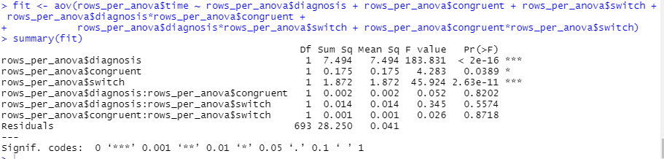

Results of the ANOVA: high significance of diagnosis and switch, but no interaction is significant => we stepwisely reduce the model until we end up obtaining the additive model tempi : diagnosi e switch.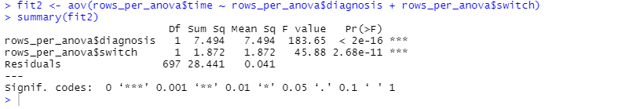

Interpretation coming from linear model/boxplot/anova: gli schizofrenici hanno una performance peggiore in termini di tempo, ma questa non è più influenzata dallo switch di quanto non lo sia per un sano ma lo **switchcost è lo stesso**.

(freccina che punta allo switchscost)

____________________

**ANALYSIS OF ERROR AND ACCURACY OF THE ANSWERS**

Does diagnosis influence the number of correct answers given by the subjects?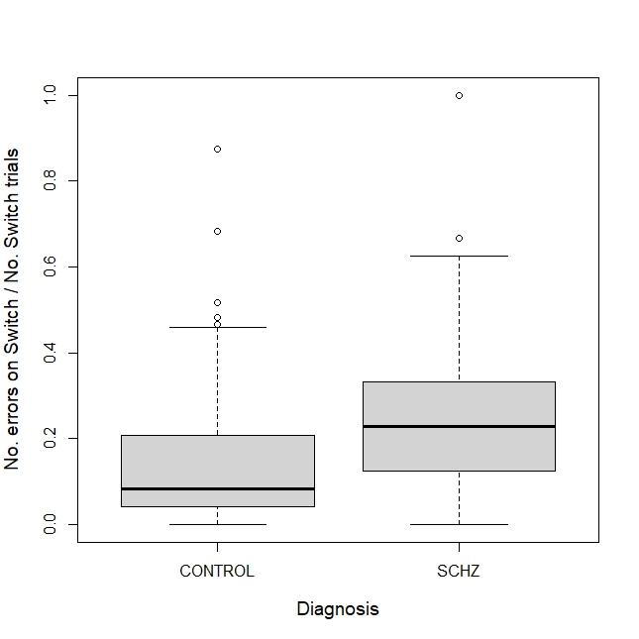

count=numero di risposte sbagliate date da ogni individuo

NSwitch = sbagliate fornite nel caso di switch

MediaRisposte = percentuale totale di risposte corrette fornite durante l’esperimento

NSwitch/$count.

gli schizofrenici in assoluto sbagliano più sullo switch dei sani

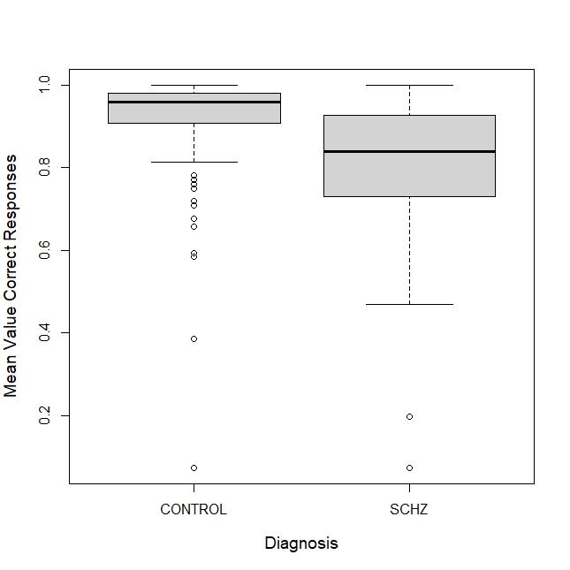

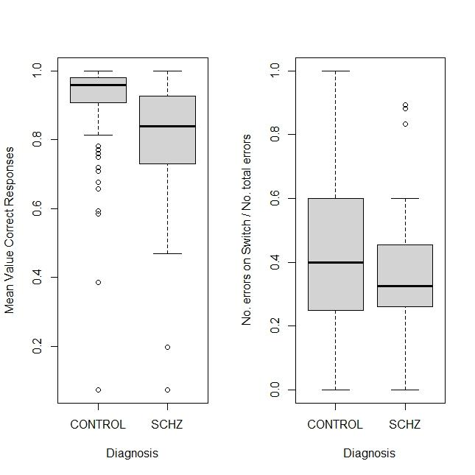

* Schizophrenic subjects have in general less accuracy
* On switch trials Schizophrenics’ perform worse (less accuracy)
* But in general neurotypicals’ errors are more concentrated on switch than schizophrenic, cioè gli schizo hanno un generale impediento, una generale low accuracy. The presence of the switch doesnt make the trial muc
* h harder.

Pur sbagliando in assoluto di più, uno schizofrenico concentra i propri errori sullo switch meno di quanto fa un sano. (Magari potremmo fare test sulla media per confrontare i boxplot)

gli schz sono sia più lenti che meno accurati, => “both groups apply similar speed/accuracy tradeoffs”

=> This is coherent with the correct-cost boxplots and tests performed in the preliminary steps.

risultati confermati da letteratura:

Gli schz hanno problemi nel mantenere il task- set: “configuration of perceptual, cognitive and response biases that serve to optimize task performance”.

(Inoltre, “RT residual switch cost is proportional to the effort required to activate and implement the new Cue-Response rule”. = questo è il tipo di attività/difficoltà che riscontrano anche i sani ed è per questo che anche loro hanno switch cost)

Conclusioni tratte in letteratura per esperimenti simili:

“Sczh suffer from more between-task interference.

This implies that the schz person needs to perform anticipatory

+reconfiguration for both switch and non-switch trials (mentre i sani lo fanno solo sullo switch). Schizophrenic patients exhibit more effortful processing (more brain activity) on non-switch trials than controls, suggesting that patients found task-repetition as difficult as task-switching.”

Quindi: “Task switching difficulties in schizophrenia do not result from a specific switching deficit, but rather from a broader difficulty in active memory for task context. In some experiments, patients needed to be reminded by the experimenter several times what responses (ex index of left hand) indicated.”

IN CONCLUSIONE, avendo ottenuto risultati coerenti con la letteratura, ci aspettiamo di trovare coerenza con i dati riportati nelle z-maps, in particolare nelle aree del cervello coinvolte per la working memory

____________________________

PCA

First, to avoid to take into account the huge noise contained in the functional connectivty map we have averaged the values on 83 regions in which the brain is typically considered to be divided into, according to their functions.

* PARAVIEW IMMAGINE DEI DUE CERVELLI, SANI E SCHZ

Afterwards we have performed PCA on these data:

* Paraview immagine delle i-th PCs
* Interpretazione i-th PC
* Score lungoi-th PC

We observe that the 3rd score is the one that discriminates the groups the most: (+ frase di scotto). Indeed

* Test fra le medie delle due popolazioni

it make sense because we indeed expected

+

_______________________________

LMM

We want to understand how the covariates diagnosis and switch influence the eaction Times so we started performing a Linear regression:

tempo di risposta ~ diagnosi + switch + congruent.

So for every subject we have different kinds of trials in 4 conditions (switch-congruent, switch-non congruent, non switch-congruent, non switch-non congruent)

First we performed an ANOVA to discriminate the 4 groups,

* Foto del risultato dell’anova

but the data related to the same subject are not independent so we used the subject as a Random Effect in questo modo:

tempo di risposta ~ diagnosi + switch + congruent + (1 | Subject)

* Foto del risultato del LMER
* PVRE
* Marginal covariance matrix
* dotplot

The PVRE is extremely high, this result suggest that we have to assign most of the real variability to the intrinsec difference between the subjects rather than the difference between the two groups (Since we don't notice any specific pattern in the random effects)

* Boxplot of the random effects in the two groups